

**1st SEMESTER (E-PROJECT)**

**Project Instructor:**

**MISS : YAMNA AYUB**

Contents

**Certifiation: 3**

**Acknolegment: 4**

**Preface 5**

**Project Synopsis** **6**

**Project Analysis 7**

**Requirment Specification 8**

**Project Sumarary 9**

**Task Sheet 10**

**Screen Shots 12-19**

**Project Certification**

This is to certify that,

**ABDUL HADI**

Has successfully designed & developed



A Project Submitted

in Partial Fulfillment of the Requirements

for the Semester of

**CPISM**



Date of Submission:

2 May 2021

Authorized Signature: **MISS YAMNA AYUB**

# ACKNOWLEDGMENT

Praise is to Almighty Allah who taught us that we knew not. All thanks to our Omnipotent Lord, for providing us with opportunity and ability to commence, explore and eventually complete the report of the project.

We take this special occasion to thanks our parents. We dedicate this work to our parents, Teachers & Faculty. It would have been simply impossible to start continue and Complete without the support of our parents who, unconditionally provided the resources to us.

We are extremely indebted to our beloved **MISS YAMNA AYUB** for his precious time, valuable ideas and above all an untiring helping hand. Mam, thank you so much.

We are also thankful to our Faculty Member for their valuable and moral support.

**Thank You.**

**PREFACE**

* First of all, we would like to thank ALLAH the Almighty, who gave us mind to think and heart to feel creativity & creation depends on thinking.

* I would like to thank all the faculty members of Aptech-Metro Star Gate. Very special thanks to our teacher of **APTECH** for his expert advice and brilliant suggestions and always encouraged us to do the best. Indeed, some class fellows are very important and we would like to thank all of them for their kind appreciation, encouragement and moral support.
* We would also like to express our deepest gratitude to our parents whose well wishes enabled us to transform our dream into a reality.

Finally, our sincere thanks to our teacher

***“MISS YAMNA AYUB”***

For all their assistance in making this concept a reality.

# PROJECT SYNOPSIS

**TITLE:**

# Rhythm House

# Objectives/Aim of the project:

* The Objective of this program is to give a project to work on real life projects. These applications help you build a larger more robust application.
* The objective is not to teach Dream Viewer/web designing but to provide with a real-life scenario and help create basic websites using the tools.

## Problem Statement:

Rhythm House is a music store in the city which offers not only music but contests and live shows too. It caters to almost all the age groups by providing the CDs, tapes of poems for kids, latest pop music collection for teenagers etc. Rhythm House also caters to a slightly older age group and boasts of the largest collection of regional and devotional music. Besides, if someone wants to pick up a good 60's or 70's rock album, chances are that he will get it here, and in case it’s not available, they will order it within a week.

# PROJECT ANALYSIS

They have the largest tape collection one can find ranging from Motion Picture Soundtracks to Rock 'n Roll. Besides music, one can find a number of music related magazines on sale. While some magazines are Indian, most of them are Air Mailed from the US and include top magazines like Guitar Legends and Total Guitar.

They also have a membership facility where in you can enroll yourself against any purchase of Rs. 200 and for subsequent purchases you can avail of points and other offers.

Looking at the growing competition, they have decided to find an easy source to reach to the customer and the solution they thought of is of building a web site which will host all the information about their shop.

They have approached you to develop site by the name rhythmhouse.com for them. The site needs to be developed based on the following set of requirements.

# Requirements Specification

A menu that will categorize all the functions of the site

Display the list of available albums category wise.

Albums can be of movies or different bands or solo performer’s collections.

Categories can be CD, DVD, Tape as well as movies, bands, Solo performers. E.g there can be CD of a movie as well as DVD and tape, all should be displayed separately.

Perform the search based on a particular

1. movie

2. band

3. solo performer

4. release year

Display the statistics of albums sold monthly.

Display the various offers/contests by the shop

Display the details (performer, time, duration, entry fee etc) of live shows

Give information about membership.

Display the available books and magazines.

Display the price list of the various items available in the shop i.e. (CDs, DVDs, Tapes, Books, Magazines)

Display the schedule and details of upcoming live shows.

Site should be able to provide brief introduction/history about the shop under About Us page

The location of the shop under Contact-Us page.

Besides the above requirements, the site should have look and feel as per the industry standards

# PROJECT SUMMARY

# ANALYSIS SUMMARY

|  |  |  |  |  |  |
| --- | --- | --- | --- | --- | --- |
| Project Ref. No. | | Project Title | Date of Preparation of Activity Pl | | |
| S.No. | Task | **RHYTHM HOUSE** | Actual Days | Team Mate Name | Status |
| 1 | Analysis | 2 | Abdul Hadi | OK |
| 2 | Design | 2 | Abdul Hadi | OK |
| 3 | Development | 8 | Abdul Hadi | OK |
| 4 | Documentation | 1 | Abdul Hadi | OK |

SCREEN SHOTS

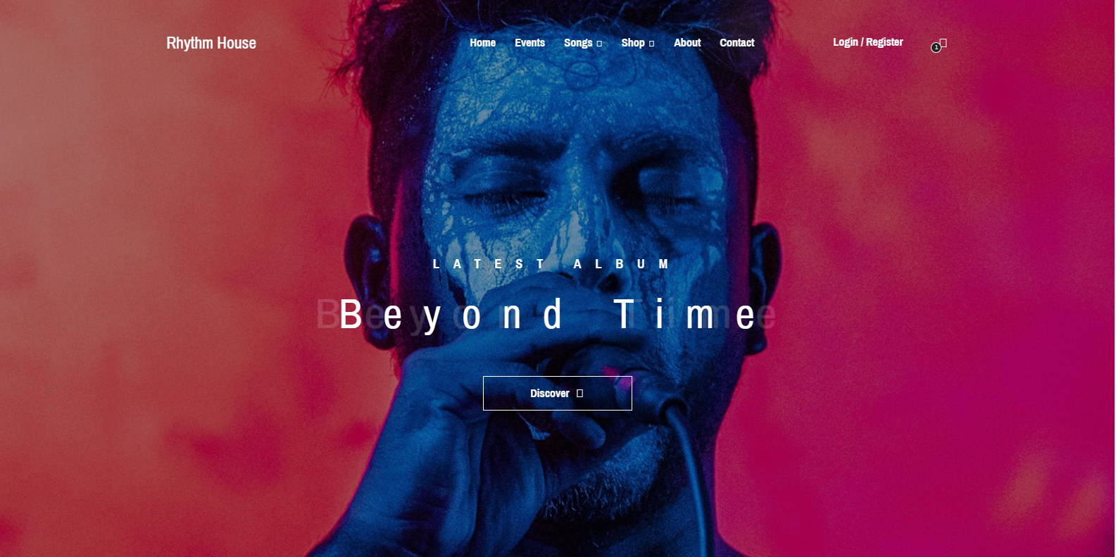

Movies:

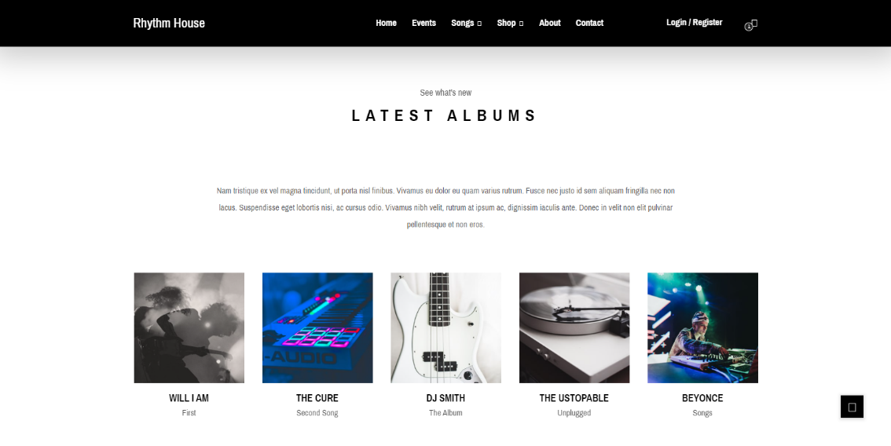

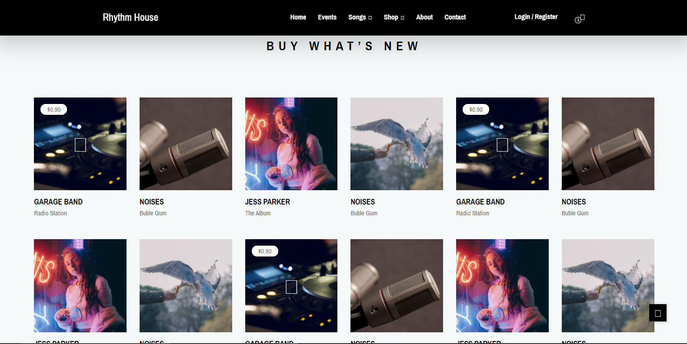

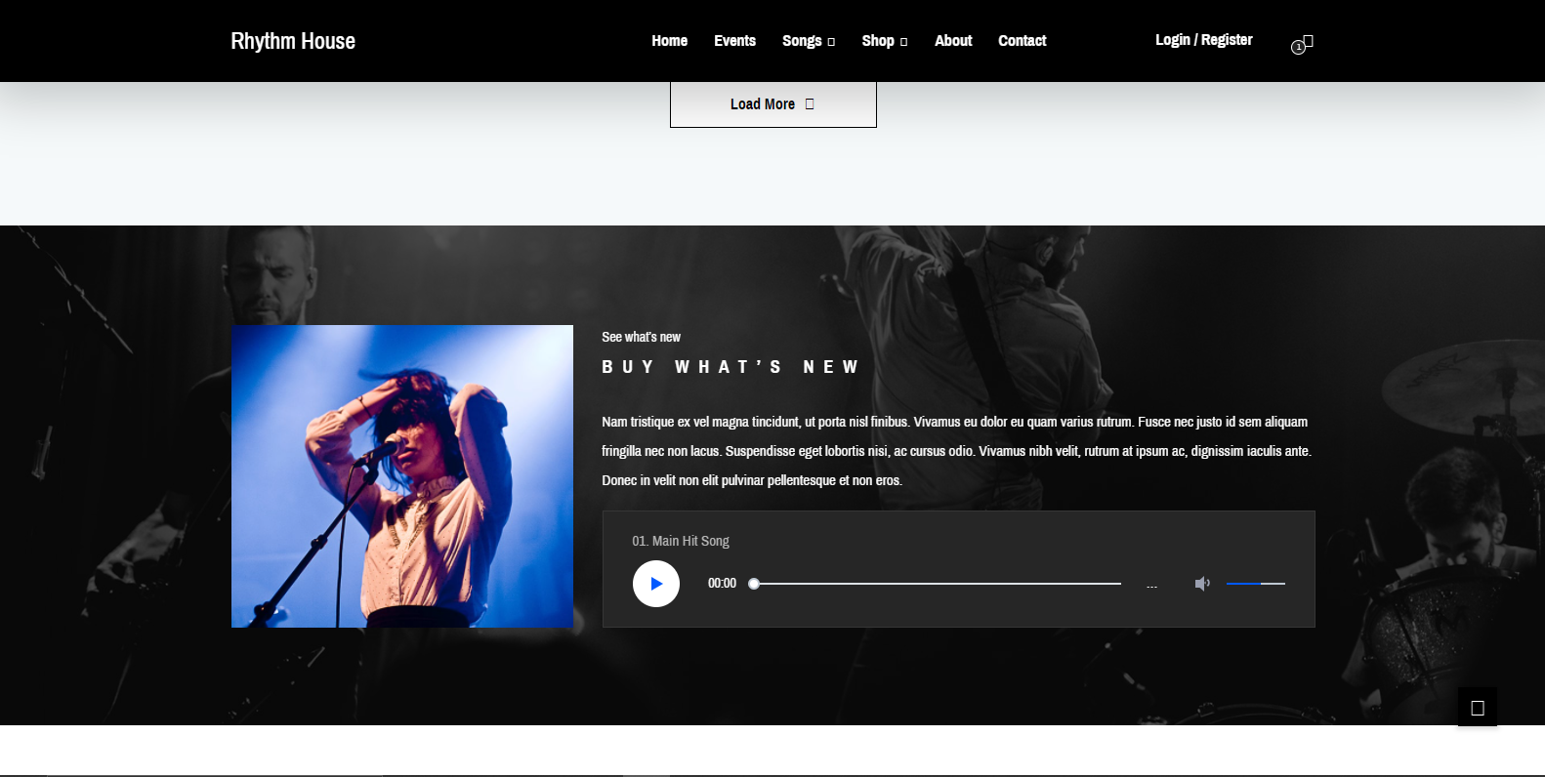

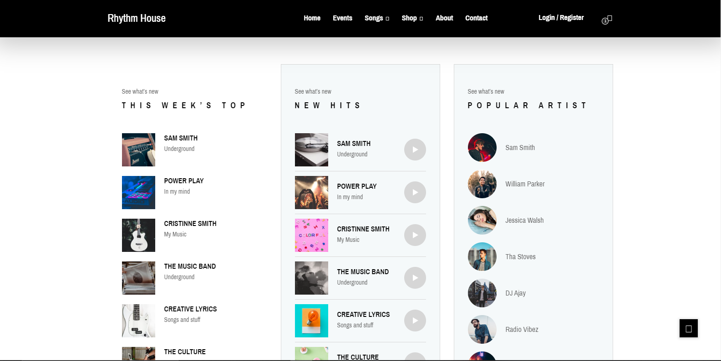

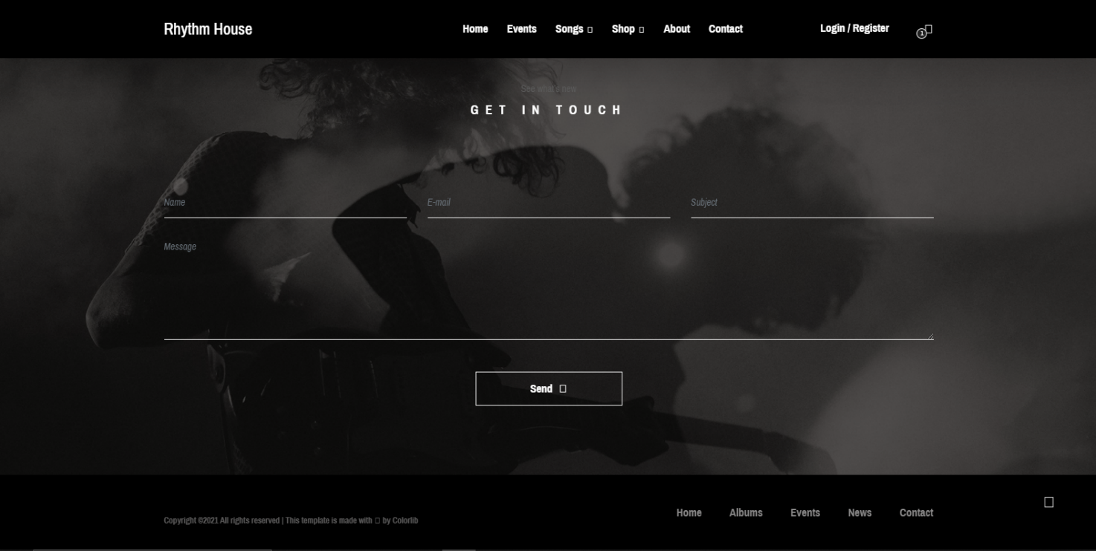

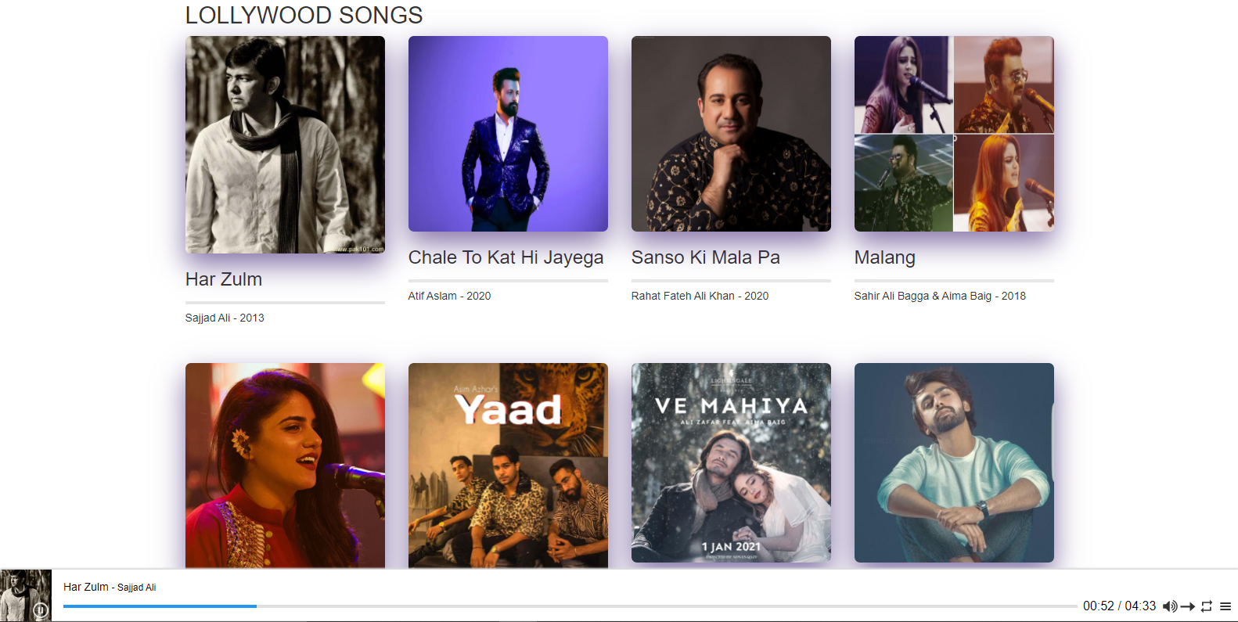

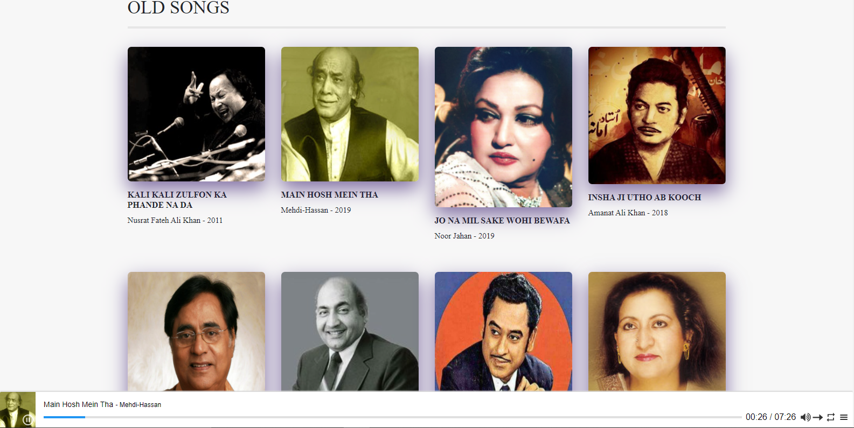

C

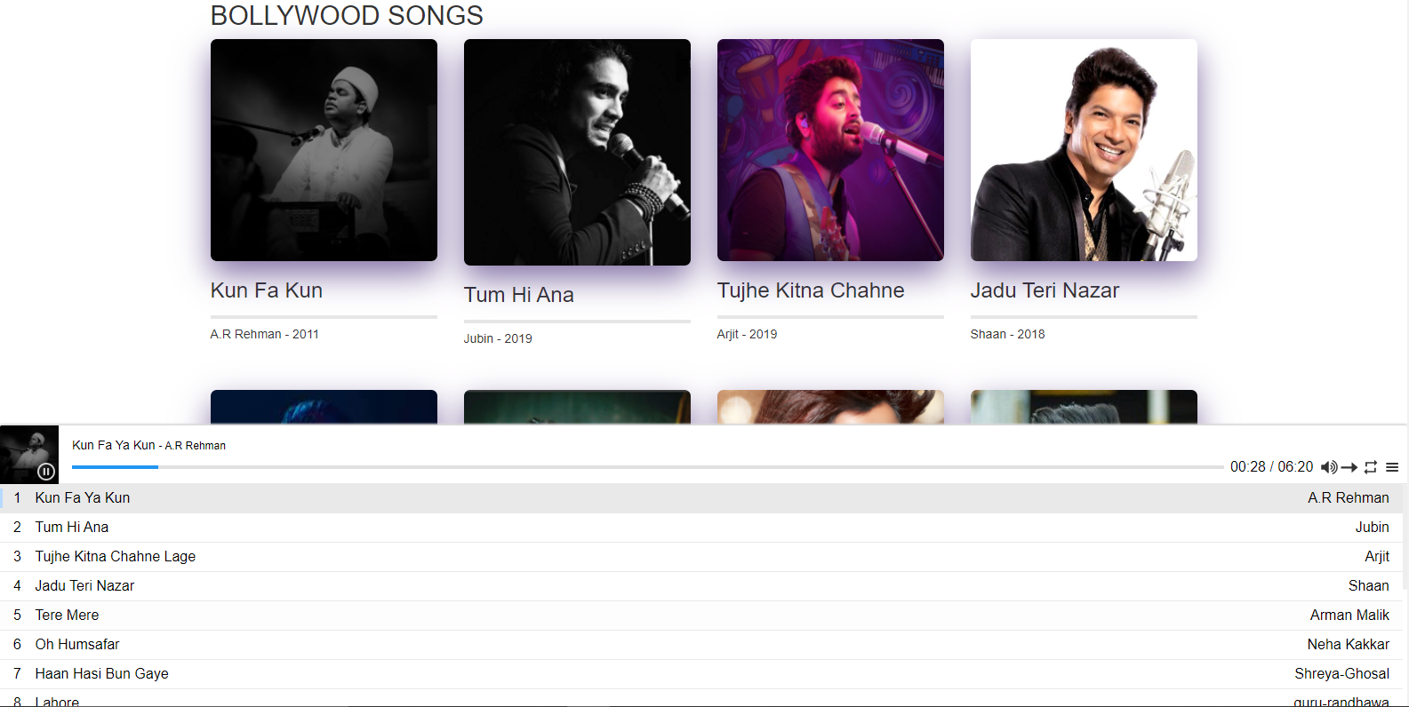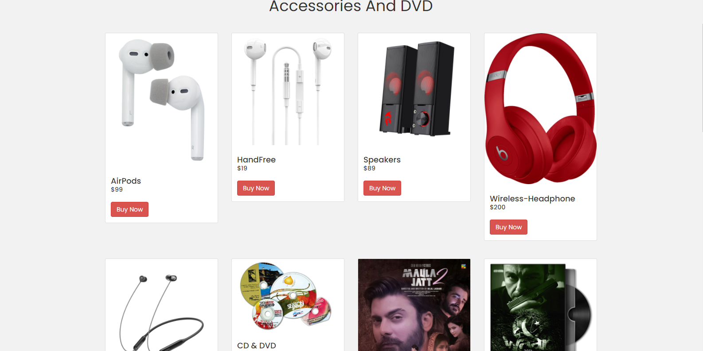

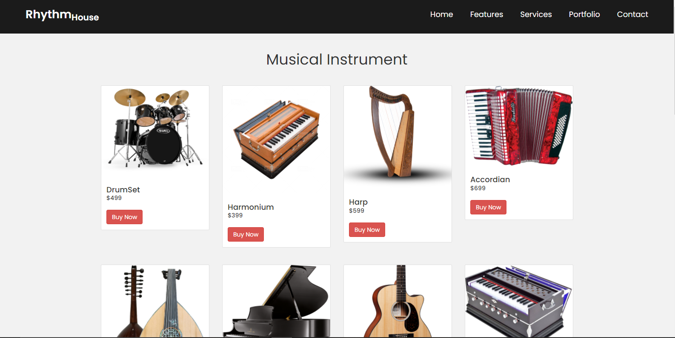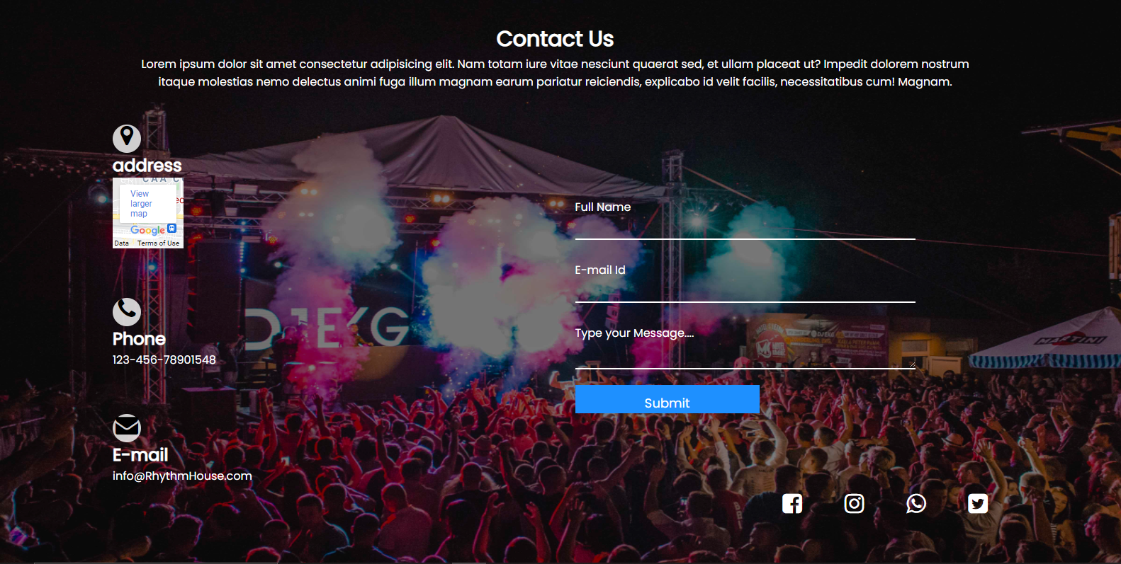

**THANK YOU**